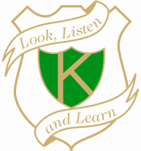
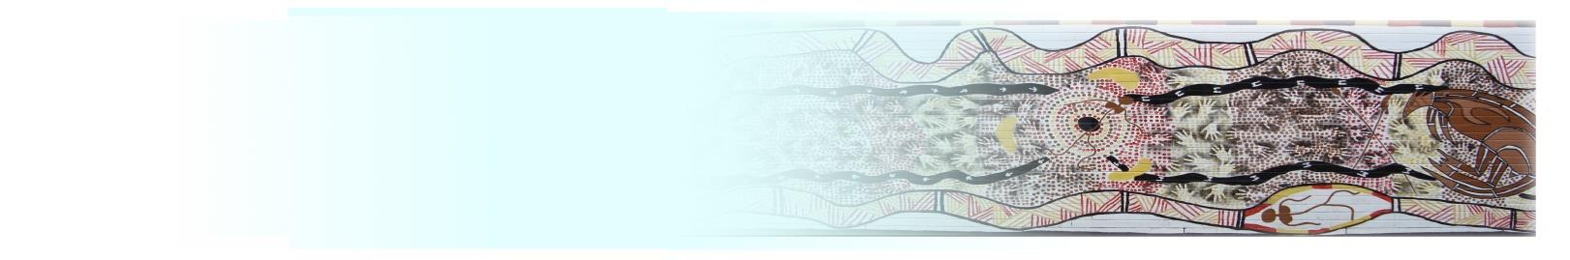
RELIGIOUS EDUCATION
POLICY

Rationale:
- Religious education is an integral part of school activities, taking place in school hours and under the jurisdiction of the school. Religious education is delivered by religious persuasions that have the approval of the Minister for Education for that purpose. Parents/caregivers in public schools have the right to have their children receive instruction in their religious persuasion, where authorised teachers of that persuasion are available. Parents/caregivers may nominate an alternative persuasion, where special religious education cannot be offered for students of a particular religious persuasion, or for other reasons. Parents/caregivers also have the right to choose not to have their children attend special religious education.

Definitions:
- Special religious education is education in the beliefs and practices of an approved religious persuasion by authorised representatives of that persuasion.
- General religious education is education about the world’s major religions, what people believe and how that belief affects their lives. It is taught mainly through the school curriculum.
- Special education in ethics is education in ethical decision making, action and reflection within a secular framework, based on a branch of philosophy.

Aims:
The Religious Education program has been established to support all students to:-
- Form their own opinions about religious beliefs and customs and that they develop an understanding and tolerance of people who hold a strong faith.
- Enjoy learning about religion because it is taught in a stimulating and interesting way that evokes their curiosity and develops positive skills and attitudes.
- Understand some of the impact of religion throughout the world, its influences on the lives of individuals and communities and its effect on the cultural diversity of their own and other societies both presently and in the past.
- Support spiritual, moral, social and cultural development by encouraging self-awareness and self-respect.
- Develop their social and moral development by encouraging a positive attitude and valuing the beliefs of others, however different from their own.
- Develop knowledge and understanding of religion as a whole and within their local community.

Implementation:
At enrolment, parents/caregivers are to be advised:
- Of special religious education options at the school, including the religious persuasions providing special religious education and arrangements made for students whose parents/caregivers indicate that they are not to attend special religious education.
- As a small school, Karuah Public School offers scripture every Monday afternoon from 1:50 to 2:30. Scripture is delivered by the local teachers from Tahlee Bible College.
- A parent/caregiver may at any time notify the school in writing that they do not wish their child to attend special religious education. Students are to continue in the same arrangement as the previous year, unless a parent/caregiver has requested a change.
- Students not attending are placed in a separate space from special religious education classes. Schools provide meaningful activities with appropriate care and supervision. These activities neither compete with special religious education nor are they lessons in the curriculum. Suitable activities include reading, private study and completing homework.

Evaluation:
Karuah Public School will annually revisit the procedures explicit within the Religious Education Policy and evaluate their currency.

This policy will become a part of the Schools Policy review cycle.

